

**WEB APP DEVELOPMENT**

**BSCS-4**

**Lab 10 TASKS**

Name: Eshal Siraj

SAP ID: 54686

Submitted to: Mam Nayab Khalid

**TASK 1:**

<?php

echo "<h4>Arithmetic Operations</h4>";

$num1 = 4;

$num2 = 8;

echo "First Number: $num1 <br>";

echo "Second Number: $num2 <br>";

echo "Addition: " . ($num1 + $num2) . "<br>";

echo "Subtraction: " . ($num1 - $num2) . "<br>";

echo "Multiplication: " . ($num1 * $num2) . "<br>";

echo "Division: " . ($num1 / $num2) . "<br>";

?>

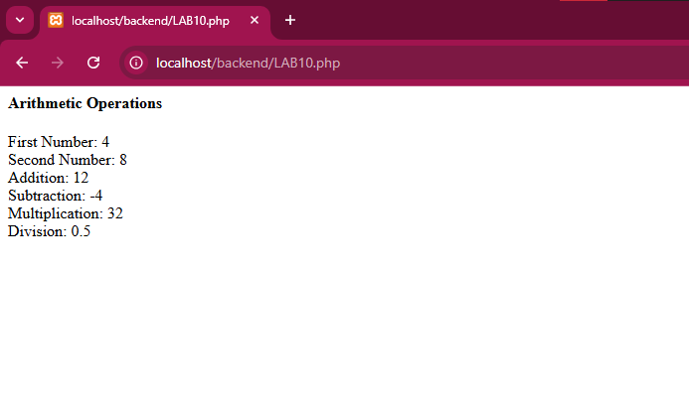

**TASK 2:**

<?php

echo "<h4>Even or Odd</h4>";

$number = 5;

echo "Number: $number <br>";

if ($number % 2 == 0) {

    echo "It is Even.<br>";

} else {

    echo "It is Odd.<br>";

}

?>

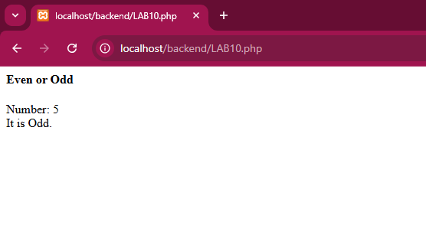

**TASK 3:**

<?php

echo "<h4> Swapping Variables</h4>";

$a = 10;

$b = 20;

echo "Before Swapping: <br> A = $a <br> B = $b<br>";

$temp = $a;

$a = $b;

$b = $temp;

echo "After Swapping:<br> A = $a <br> B = $b<br>";

?>

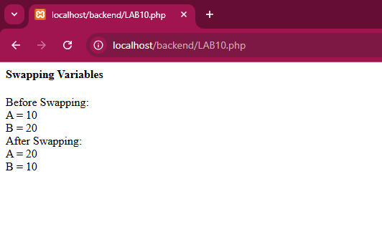

**TASK 4:**

<?PHP

echo "<h4>Greatest Number</h4>";

$x = 35;

$y = 14;

$z = 37;

echo "Numbers: <BR>  X = $x <BR> Y = $y <BR> Z = $z <br>";

if ($x >= $y && $x >= $z) {

    echo "Greatest is X: $x<br>";

} elseif ($y >= $x && $y >= $z) {

    echo "Greatest is Y: $y<br>";

} else {

    echo "Greatest is Z: $z<br>";

}

?>

